My Uncle son shot and killed by the Cameroon military in December 2017

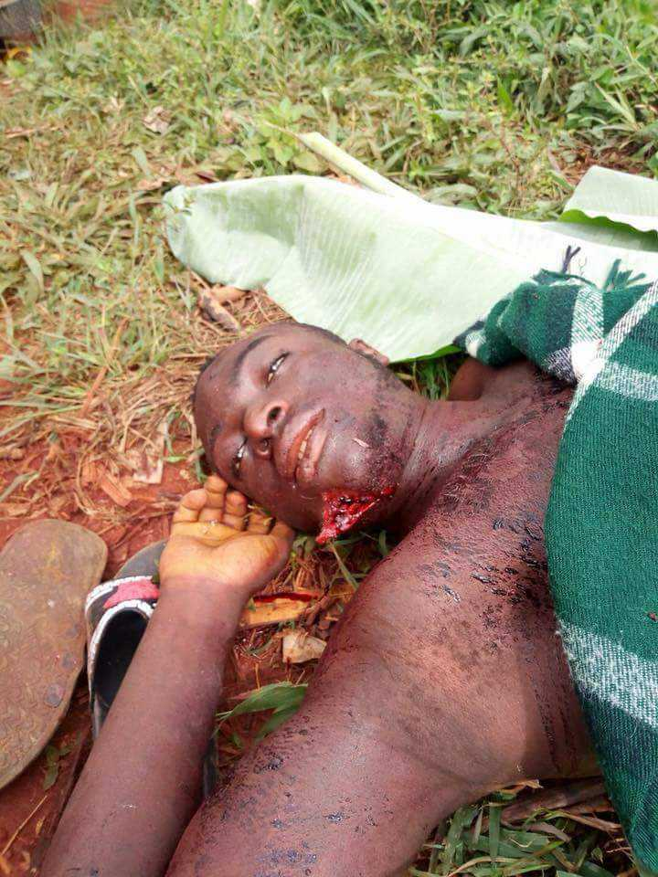

Godwill Foundation worker (Besong Florence) shot and killed by the Cameroon military in December 2017



Godwill Foundation former Secretary General, Agbor Paul finger chopped off and was later shot dead by the Cameroon military.
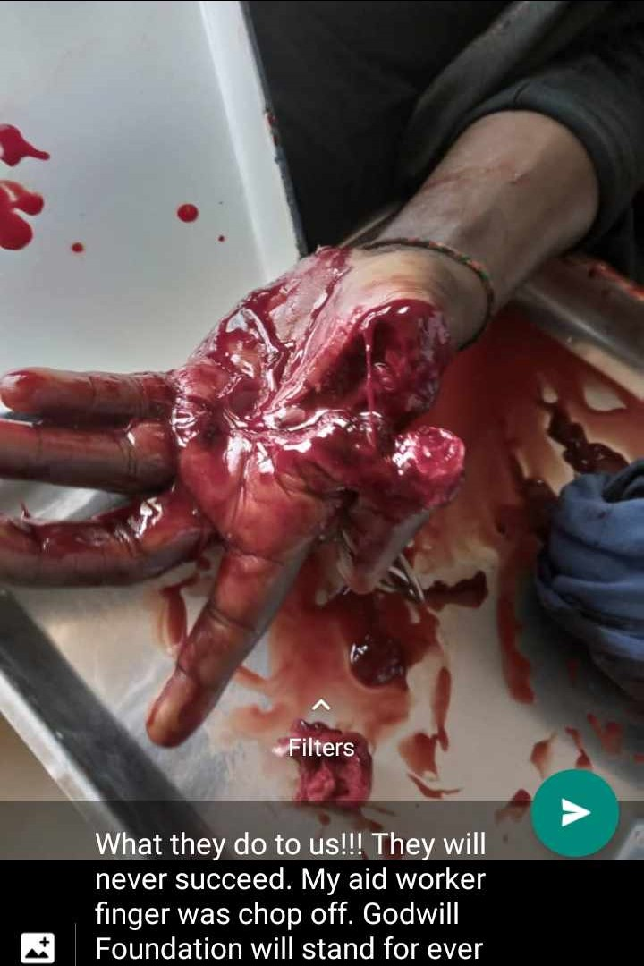

Godwill Atem Atem leading protest in front of the chief palace in January 2013 with placards and peace plants
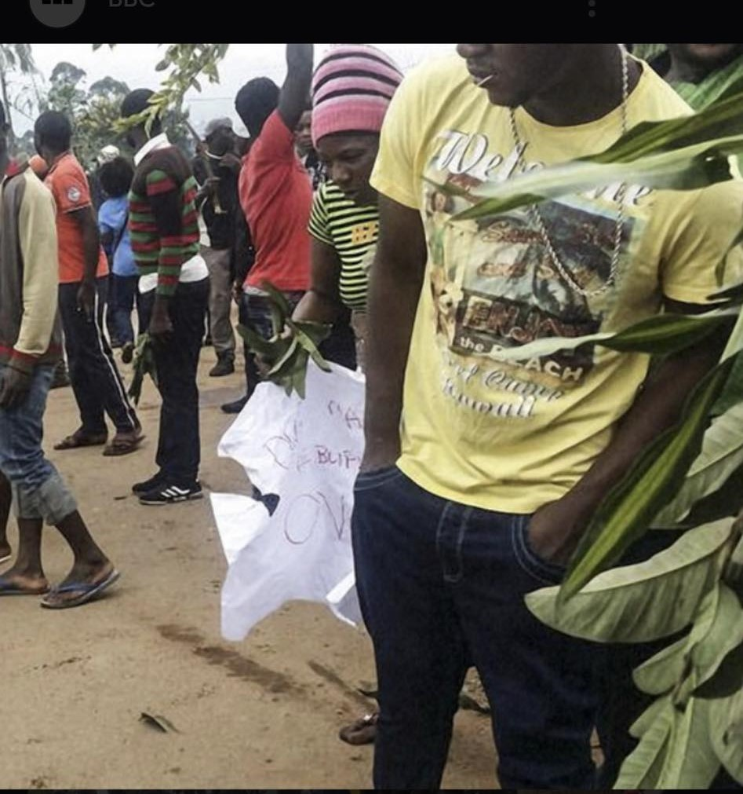

Our house burned down by the Cameroon military

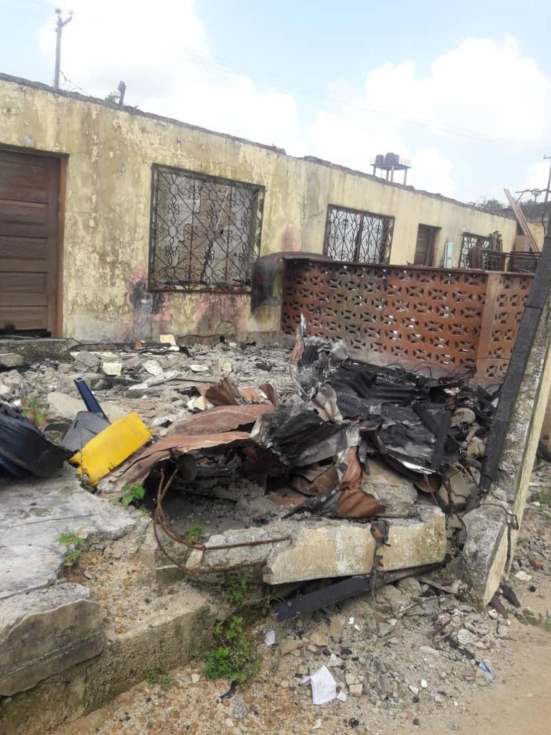

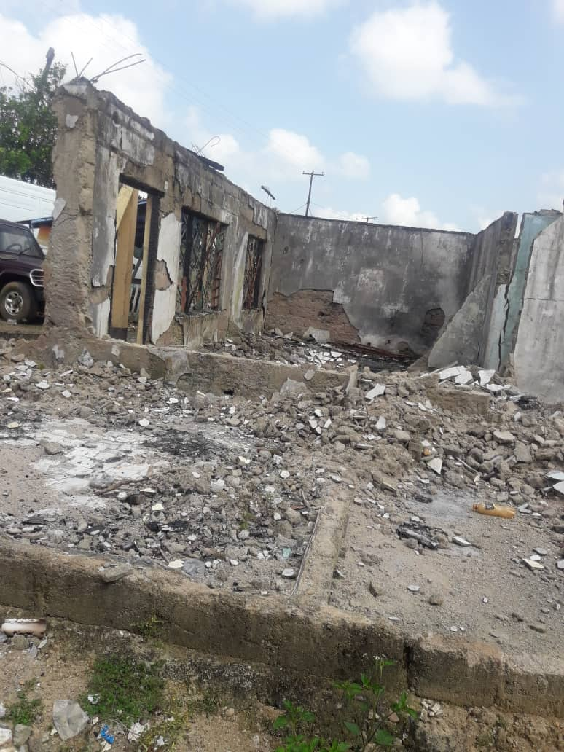

Our cocoa farm burned down by the Cameron military
